Lillian Tran

Feudalism Lesson
Critical Thinking Questions:

- Why did feudalism develop?
- How did feudalism affect the political, social, and economic environment of medieval Europe?
- What’s the benefit of having one king instead of three different kings?
- Analyze this map:
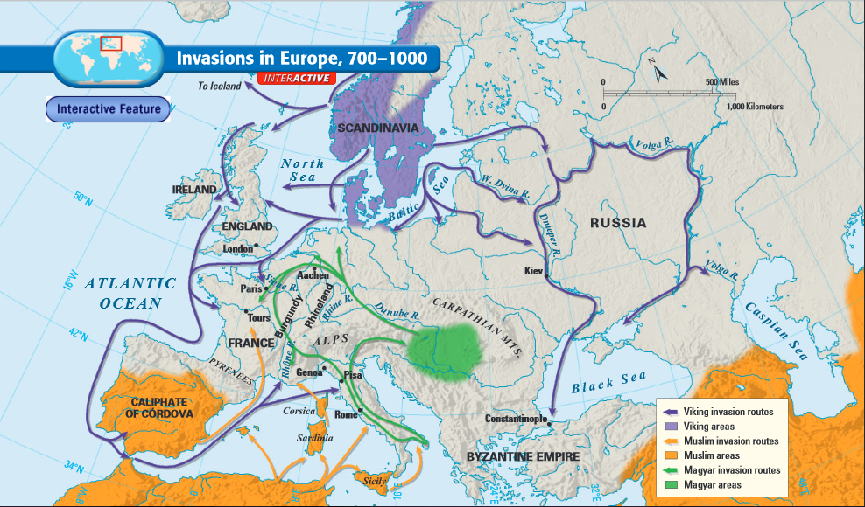
A) What lands did the Vikings raid?
B) Why were these invasions so threatening to Europe?
- What was the impact of Viking, Magyar, and Muslim invasions on medieval Europe?
- Make an inference. How and why did peasants endure such a lifestyle? What benefits did they receive from living on a manor?
- What social class would you want to be part of if you were living in medieval Europe, and why?

