How to Analyze Primary Source Documents

Key Historical Question: Based on the following documents, what can you tell about the values of the people living in Europe during the Middle Ages?

Document A

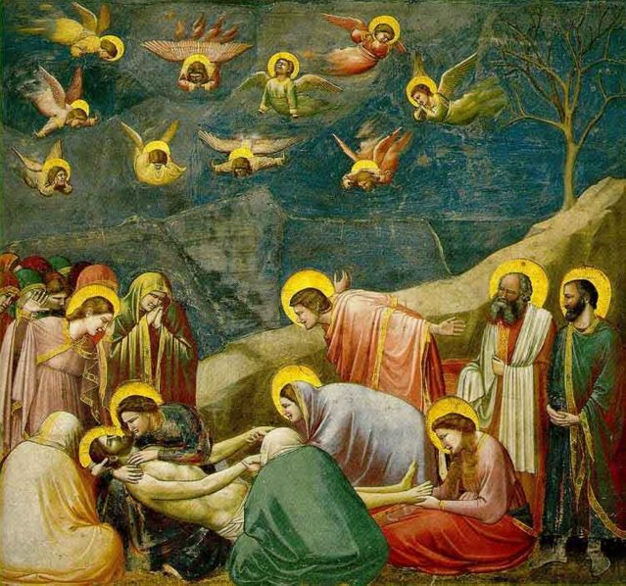

Lamentation. Giotto. dated 1305-1306. This 7' 7" x 7' 9" fresco can be seen in the Arena Chapel in Padua, Italy. The work depicts the Lamentation or Mourning of Christ.

Document B
A Frankish Formula of Commendation, Seventh Century.
Who commends himself in the power of another:
To that magnificent lord so and so, I, so and so. Since it is known familiarly to all how little I have whence to feed and clothe myself, I have therefore petitioned your piety, and your good-will has decreed to me that I should hand myself over or commend myself to your guardianship, which I have thereupon done; that is to say in this way, that you should aid and succor me as well with food as with clothing, according as I shall be able to serve you and deserve it.
And so long as I shall live I ought to provide service and honor to you, suitably to my free condition; and I shall not during the time of my life have the ability to withdraw from your power or guardianship; but must remain during the days of my life under your power or defence. Wherefore it is proper that if either of us shall wish to withdraw himself from these agreements, he shall pay so many shillings to the other party (pari suo), and this agreement shall remain unbroken.

How to Analyze Primary Source Documents

Key Questions to Ask Yourself:
- Source - Who is the author? Is the document and/or its author a reliable source?
- Context - When, where, and for whom was this document created?
- Close read - What are key words or images in the document? What do those key words and images mean? What inferences can I make about this text? How is this document significant to history?
- Corroborate - How does this document compare and contrast with other documents from this time period? What might account for the differences? How can I use these multiple documents to support my ideas about this historical event?

Key Decoding Strategies:
- Circle words that are unfamiliar.
- Use context clues to help define.
- Look up the meaning of unknown words.
- Write synonyms for these new words in the text.
- Underline important places and people and identify.
- Read aloud.
- Read multiple times.

Key Historical Question: Based on the following documents, what can you tell about the values of the people living in Europe during the Middle Ages?

Document (Write the number/letter of the document.) | Notes  (Circle and define unknown words, write down initial reactions, key words or ideas, thoughts, and ideas.) | Summarize Meaning  (Reread notes and summarize the overall meaning of the document.) | Historical Significance  (Discuss how this document might answer key historical questions or why it is important to history.)

