Living in Medieval Europe Project

Final Due Date: ___________________

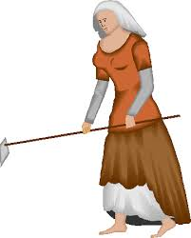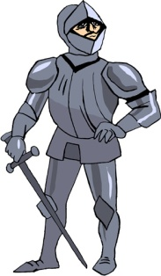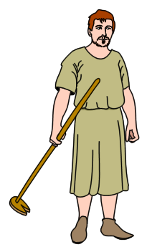

Project Grouping: Individual

Overview: In this project, you will demonstrate your understanding of what life was like in Medieval Europe by producing a short story from the perspective of a character living in Europe during the Middle Ages. This story will be a piece of historical fiction, a genre which presents people and events from the point of view of characters of a historical time period.

Directions: You will use your imagination and knowledge of Medieval Europe to invent a medieval character and tell a first person story about the life of this character. You will develop a plot and use narrative techniques, such as sensory description and dialogue to bring your story to life. Within your story, you must describe basic things about the person's life, such as his or her social status or position, family situation, eating habits, living quarters, work, etc. In addition, you will need to describe this character's life within the political, social, religious, economic trends of the time. To create a historically accurate portrayal of your character, you must use and cite at least four different secondary sources in your research of the time period.

Requirements:
- Invent a medieval character and tell a story in first person perspective (I, me, we) about the life of this character. (Character ideas: pope, king, peasant, crusader, knight, noble, monk, etc.)
- Develop a plot (exposition, rising actions, climax, falling action, resolution) and organize your story into at least five paragraphs.
- Describe important details about this person's life in a fictional, but historically accurate manner (ex. character's name, family, social status, eating and living habits, work, etc.). Be sure the reader knows the "who," "what," "when," and "where" of the story.
- Include details about the historical trends of the period - the political, social, economic, and religious situation of the time. You must discuss at least three out of the four categories.
- Use narrative techniques, such as sensory description and dialogue.
- Use correct spelling, grammar, punctuation, and MLA format.
- The story must be typed, double-spaced, with 12-point, Times New Roman font.
- Research and cite at least four different secondary sources in MLA format. Include a separate works cited page and attach it at the end of your story.

