Medieval Europe: Feudalism Lecture
Guided Notes

Directions: Follow along these notes during lecture and fill in the missing blanks with the correct terms. Also be sure to jot down your answers at each "Question to Ponder" in the lines provided. At the end of the notes, reflect on the main ideas of the lesson and what you just learned by answering the two Essential Questions.
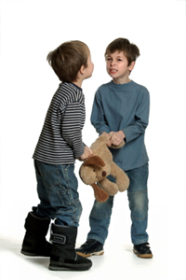
THE CAUSES OF FEUDALISM
"Setting the Stage for Feudalism"
- Emperor Charlemagne’s son dies and leaves the empire to his three sons
- The three sons - Lothair, Charles the Bald, and Louis the German go to war for control of the Empire
- They finally stop fighting and sign the ____________________, dividing the empire into three kingdoms

Question to Ponder: What’s the benefit of having one king instead of three different kings?
____________________________________________________________________________________________________________________________________________________________________________________________________________________________________________________________________________________________________________________________________________________

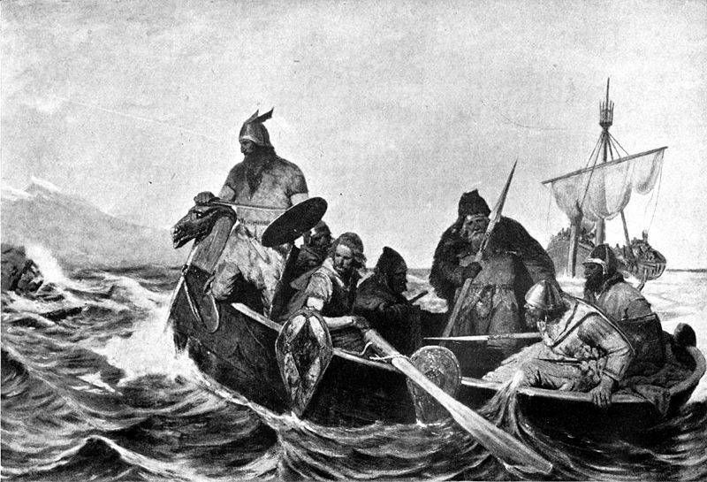
"Disunity Causes invasions"
- 800 to 1000 C.E. – invasion destroyed the Carolingian Empire
- Who invaded?
  - ____________ from the South
  - ____________ from the East
  - ____________ from the North
- The Vikings are:
  - Germanic peoples from _____________________
  - Worshipped warlike gods
  - Attacked and raided villages with great _________________
  - Known for their _______________ and sailing skills
  - Discovered the Americas before __________________ did!
- Analyze the map.
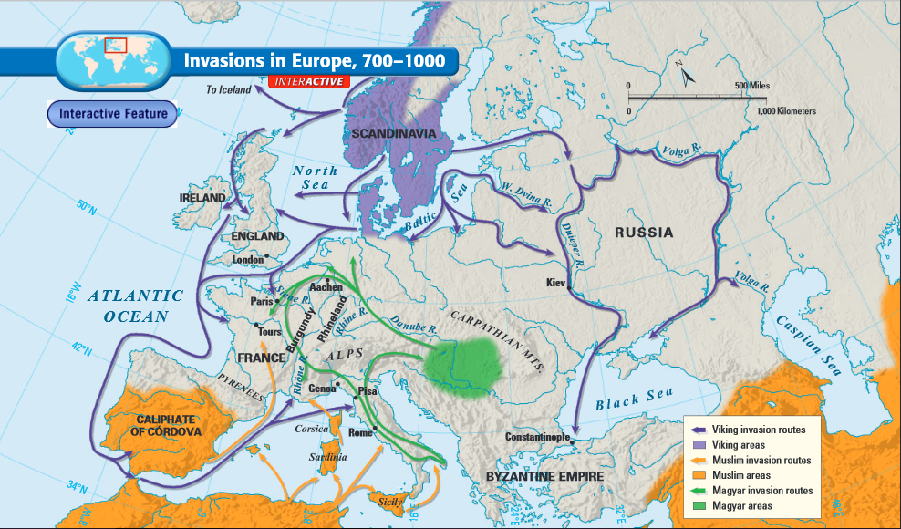

Analysis. What lands did the Vikings raid and why were these invasions so threatening to Europe?
_______________________________________________________________________________________________________________________________________________________________________________________________________________________________________________________________

Question to Ponder: What was the impact of Viking, Magyar, and Muslim invasions on medieval Europe?
_______________________________________________________________________________________________________________________________________________________________________________________________________________________________________________________________

- People in Western Europe lived in constant _________
- Kings were _____________ to defend their lands from invasion
- People no longer looked to a central ruler for security
- They start to turn to _____________ who have their own armies
- These local rulers start to gain followers and political power: Feudalism emerges

FEUDALISM
"What is Feudalism?"
- A political and economic system based on land ownership and personal loyalty
- Based on rights, obligations, and mutually-beneficial agreements (both sides gain something)
- _________________- landowners, granted fiefs in return for military service
- _________________ - land that’s given to the vassal from the lord
- _________________ - the person receiving the fief from the lord in return for his military loyalty and service to the lord
- _________________ - mounted horsemen who pledged to defend their lords’ lands in exchange for fiefs
- _________________- peasants who were tied to the land (can’t leave the place they were born) and farmed the land.
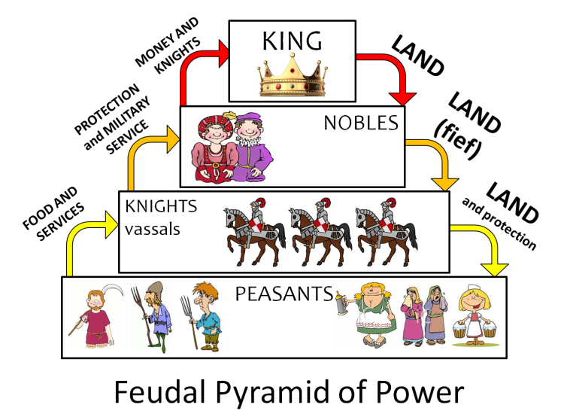

EFFECTS OF FEUDALISM
"Life as a Peasant"
- Never traveled – worked all day for their entire lives (from childhood to adulthood – if they survived that long)
- Short life spans – about 35 years
- Lived in small cottages (1-2 rooms), slept on piles of straw, had dirt-floors, ate simple diet
- Owed their lord certain duties, such as a few days of labor per week and some of their grain
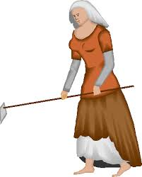
- Everything they farmed and produced technically belonged to the lord
- They also had to pay taxes on everything – even getting married!
- Had to get permission from the lord for many decisions
- Also had to pay ________ – a church tax

"Manor Life was a Tough Life"
- ____________________ - the Lord’s estate (land), the basic economic system of the time
  - Based on the rights and obligations between a lord and his serfs
  - The lord gets people to take care of his animals, land, and home
  - Peasants get housing, farmland, and protection from bandits
  - Each manor was like a mini town: the lord’s house, a church, workshops, a mill,15-30 families in a village
  - Produced everything they needed in the manor

Question to Ponder: How and why did peasants endure such a lifestyle? What benefits did they receive from living on a manor?
____________________________________________________________________________________________________________________________________________________________________________________________________________________________________________________________________________________________________________________________________________________

SUMMARY
1. Why did feudalism develop?
__________________________________________________________________________________________________________________________________________________________________________
_____________________________________________________________________________________

2. How did feudalism affect the political, social, and economic environment of medieval Europe?
__________________________________________________________________________________________________________________________________________________________________________
_____________________________________________________________________________________

3. What social class would you want to be part of if you were living in medieval Europe, and why?
_____________________________________________________________________________________
__________________________________________________________________________________________________________________________________________________________________________

