Primary Source Documents

Key Historical Question: What political and intellectual/cultural role did the Catholic Church play in the lives of Medieval Europeans? How and why did secular rulers and the church both cooperate and conflict with each other?

Document A

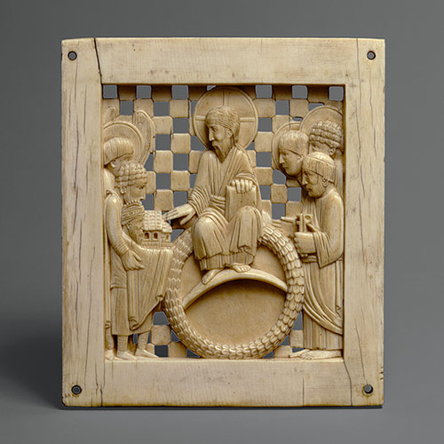

Plaque with Otto I presenting the Cathedral of Magdeburg, 962–968. Ottonian; From the Cathedral of Magdeburg, probably made in Milan, northern Italy. Ivory; 5 x 4 1/2 in. (12.7 x 11.4 cm). Gift of George Blumenthal, 1941 (http://www.metmuseum.org/toah/works-of-art/41.100.157)

Document B

"CHAPTER I. CONCERNING THE EMBASSY SENT OUT BY THE LORD EMPEROR." Capitulary of Charlemagne Issued in the Year 802. (From "Mon. Germ. hiss." [Quarto Series] LL. IL., p. 91 99; also to be found in " Altmann u. Bernheim," p. 4.)

"The most serene and most Christian emperor Charles, did choose from among his nobles the most prudent and the wisest men archbishops as well as other bishops, and venerable abbots, and pious laymen and did send them over his whole kingdom; and did grant through them, by means of all the following provisions, that men should live according to law and right. He did order them, moreover, that, where anything is contained in the law that is otherwise than according to right and justice, they should inquire into this most diligently, and make it known to him: and he, God granting, hopes to better it. And let no one, through his cleverness or astuteness-as many are accustomed to do-dare to oppose the written law, or the sentence passed upon him, or to prevail against the churches of God or the poor, or widows, or minors, or any Christian man. But all should live together according to the precept of God in a just manner and under just judgment, and each one should be admonished to live in unity with the others in his occupation or calling. [...] all should live together in mutual charity and perfect peace."

Document C

POPE GREGORY, in Basic Documents in Medieval History about Henry IV. 1077.

"There, having laid aside all the belongings of royalty, wretchedly, with bare feet and clad in wool, he [Henry IV] continued for three days to stand before the gate of the castle. Nor did he desist from imploring with many tears the aid and consolation of the apostolic mercy until he had moved all of those who were present there."

Document D

The Bull of Pope Adrian IV Empowering Henry II to Conquer Ireland. A.D. 1155 (Lyttleton's "Life of Henry II.," vol. v. p. 371.)
"Bishop Adrian, servant of the servants of God, sends to his dearest son in Christ, the illustrious king of the English, greeting and apostolic benediction. Laudably and profitably enough thy magnificence thinks of extending thy glorious name on earth, and of heaping up rewards of eternal felicity in Heaven, inasmuch as, like a good catholic prince, thou dost endeavour to enlarge the bounds of the church, to declare the truth of the Christian faith to ignorant and barbarous nations, and to extirpate the plants of evil from the field of the Lord. [...], by God's help, thou wilt progress favourably in the same; for the reason that those things which have taken their rise from ardour of faith and love of religion are accustomed always to come to a good end and termination."

